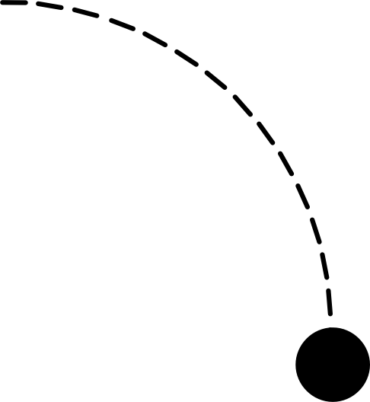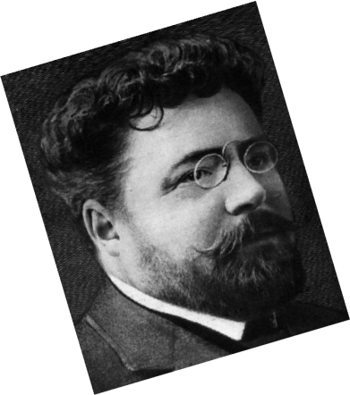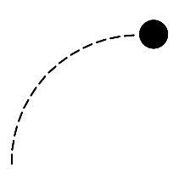

FULL NAME: Gaston Louis Alfred Leroux

# Gaston Leoux

BIRTH PLACE: Paris, France.

BIRTH DATE: 6 May 1868

Fill in t e FBI’s file fo te suspect Gaston Le oux

RESIDENCE: Paris.

PROFESSION: French journalist and novelist.

novelist.

PARENTS :

Father: Dominique Alfred

Leroux

Mother: Marie Bidault

5ft 6 aprox GASTONLEROUX

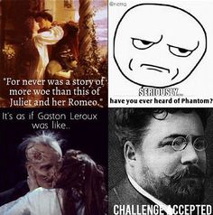 80 kg

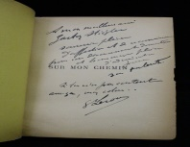

BOOKS WRITTEN: The most famous ones are:

1. The Mystery of the Yellow Room (1908)

2. The Perfume of the Lady in Black (1909)

**3. Le fantôme de l'Opéra (1910)**

OFFSPRING? Alfred Gastón

Madeleine Aile.

SINGLE/MARRIED ? Marie Lefranc

DEATH DATE: 15 April 1927 (aged 58).

PLACE OF DEATH: Nice, France

PLACE OF TOMB: Cimetière du Château (Nice, France)